CHAPTER THREE

DESIGN AND METHODOLOGY

3.1 The Proposed System
The proposed system is a web-based fundraising platform designed to enable students to create and manage fundraising campaigns with ease. Through this platform, students can present their causes, receive financial support from donors, and maintain accurate records of contributions. Donors, on the other hand, are able to browse active campaigns and make contributions using secure and convenient payment methods such as mobile money and bank transfers.
In addition, the system incorporates an administrative module that provides oversight of all activities on the platform. The administrator is responsible for monitoring campaigns, managing user accounts, and ensuring transparency and accountability within the fundraising process.
By leveraging digital technologies, the system eliminates the traditional need for students to move from office to office in search of assistance. Instead, it offers a more efficient and scalable solution, allowing campaigns to reach a wider audience within the campus community and beyond.

3.2 System Specification

3.2.1 Functional Requirements
Functional requirements define the essential operations that the proposed system must perform in order to achieve its objectives. These requirements represent the core actions and processes that ensure the fundraising platform serves its intended purpose. The major functional requirements include:
- User Registration and Login: The system must allow students, donors and administrators to create accounts and securely log in using unique credentials.
- Campaign Creation: Students should be able to initiate fundraising campaigns by providing details such as the campaign title, description, goal amount and category.
- Administrator Approval: Campaigns created by students must be reviewed and approved by an administrator before being published. This ensures that only legitimate and relevant campaigns are displayed on the platform.
- Donation Feature: Donors must be able to browse approved campaigns and contribute funds easily through supported payment methods such as mobile money or bank transfers.
- Automatic Progress Updates: The system should automatically update the total amount raised for each campaign as donations are made, providing real-time progress tracking.
- Notifications: Users must receive system alerts or email notifications regarding key activities, such as successful donations, campaign approvals or achievement of fundraising goals.
- Reports and Management: Administrators should be able to generate reports on donations, campaign performance and user activities to support effective management and decision-making.
- Search and Filter: The platform must provide search and filter functionalities to enable donors to find campaigns based on criteria such as title, category or target amount.
- Secure Transactions: All donation records and personal data must be securely stored and processed to protect the privacy and financial safety of users.
- Campaign Tracking: Users should be able to track the progress of their campaigns and view updates on causes they have supported.

3.2.2 Non-Functional Requirements
Non-functional requirements describe the quality attributes that determine how the system performs beyond its basic operations. They are critical for ensuring user satisfaction, system reliability, and overall efficiency of the platform. The key non-functional requirements include:
- Fast Loading Time: Pages and system actions should load within three seconds to provide a smooth and responsive user experience.
- Ease of Use: The interface should be intuitive and simple, allowing users of different skill levels to navigate and interact with the system without difficulty.
- Device Compatibility: The platform must function effectively across various devices, including smartphones, tablets and desktop computers.
- Security: User login credentials, personal data and financial information must be protected using secure authentication methods and encryption standards.
- High Availability: The system should remain accessible with minimal downtime, targeting at least 99% uptime to ensure reliability.
- Data Backup: Regular automated backups should be implemented to safeguard against data loss in the event of system failure.
- Responsive Design: The user interface must adapt seamlessly to different screen sizes and device types, ensuring consistent usability.
- Error-Free Donations: Financial transactions should be processed accurately and reliably, with safeguards against bugs or payment errors.
- Accessibility Support: The system should accommodate users with disabilities by providing accessible features such as readable text and clear navigation.
- Activity Logging: All significant system actions should be logged to maintain transparency and support auditing when necessary.

3.3 Selection of Technologies and Tools
The design and development of the proposed fundraising platform require the use of appropriate technologies to ensure that the system is user-friendly, reliable and scalable. The following tools and technologies have been selected:
- Frontend (HTML, CSS, JavaScript)
These core web technologies will be used to design and implement the user interface. HTML provides the structure of the web pages, CSS ensures proper styling and responsiveness, while JavaScript adds interactivity and improves user experience.
- Backend (Python with Django)
The backend of the system will be developed using Python, supported by the Django framework. Django is chosen because of its strong security features, scalability, and ability to simplify complex web development tasks through built-in components.
- Database (MySQL)
A relational database management system will be used to store structured data, including user accounts, campaign details and donation transactions. MySQL is selected due to its efficiency, reliability and wide adoption in web-based systems.
- Cloud Deployment (Heroku)
The entire system will be hosted on Heroku, a cloud-based platform that supports easy deployment and scalability. This ensures the application can be accessed from anywhere while minimizing the need for local infrastructure management.

3.4 Architecture of The System
The campus Fundraising System is designed using a three-layer architecture, which separates the system into distinct parts, making it easier to manage, maintain and scale (Pressman & Maxim, 2014). The layers are:
- User Interface Layer: This is what the user interacts with. It includes webpages for viewing campaigns, making donations, and managing accounts.
- Logic Layer: This layer processes user actions and enforces system rules. It handles functions such as validating user input, calculating donation totals, and controlling access permissions.
- Database Layer: This layer stores all system data, including user information, campaign details and donations.

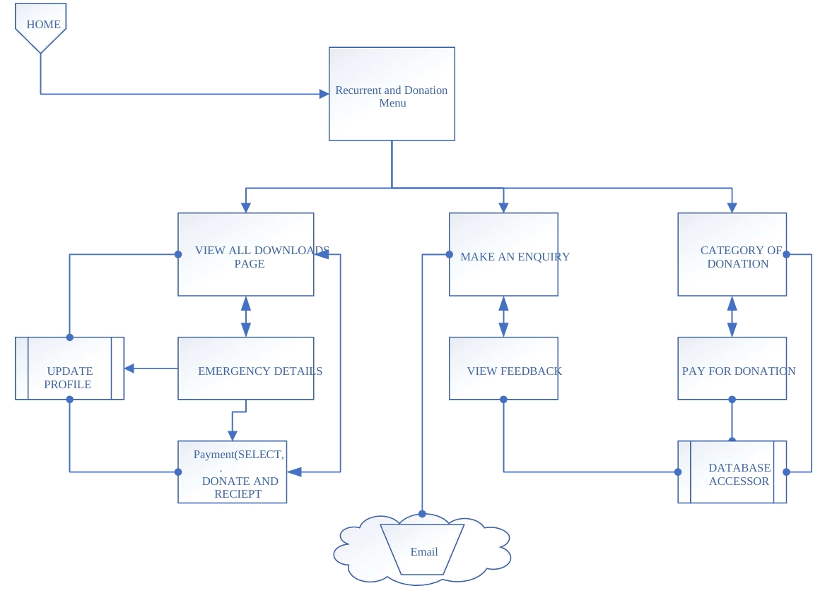
Fig. 3.1

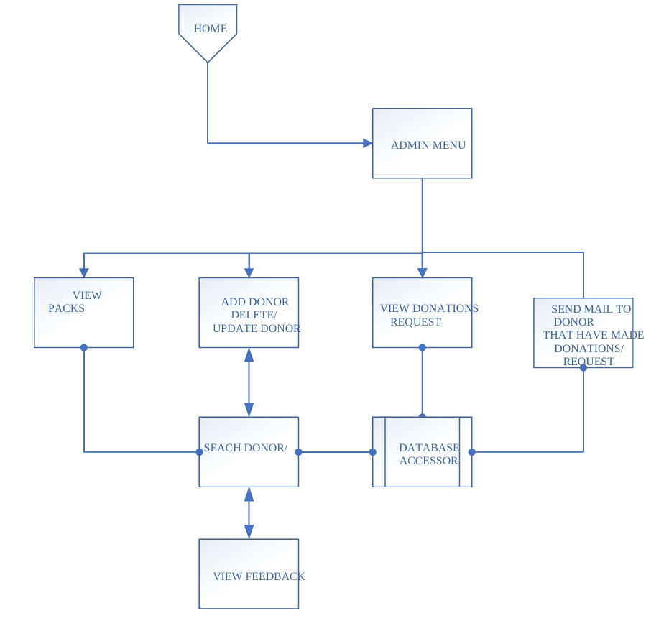
Fig. 3.2

3.5 Design of the system
The design phase involves developing the conceptual and logical frameworks of the Campus Fundraising System. This phase encompasses the planning of user interaction flows, system workflows and data organization to ensure the system is structured, efficient and user-friendly.

3.5.1 Use Case Design
A Use Case Diagram illustrates how users interact with a system. It highlights the system’s functionalities from the users’ perspective and identifies the various tasks or actions that users (referred to as actors) perform. This diagram provides a clear overview of the system’s capabilities and the relationships between different actors and use cases, facilitating better understanding and analysis of system requirements.
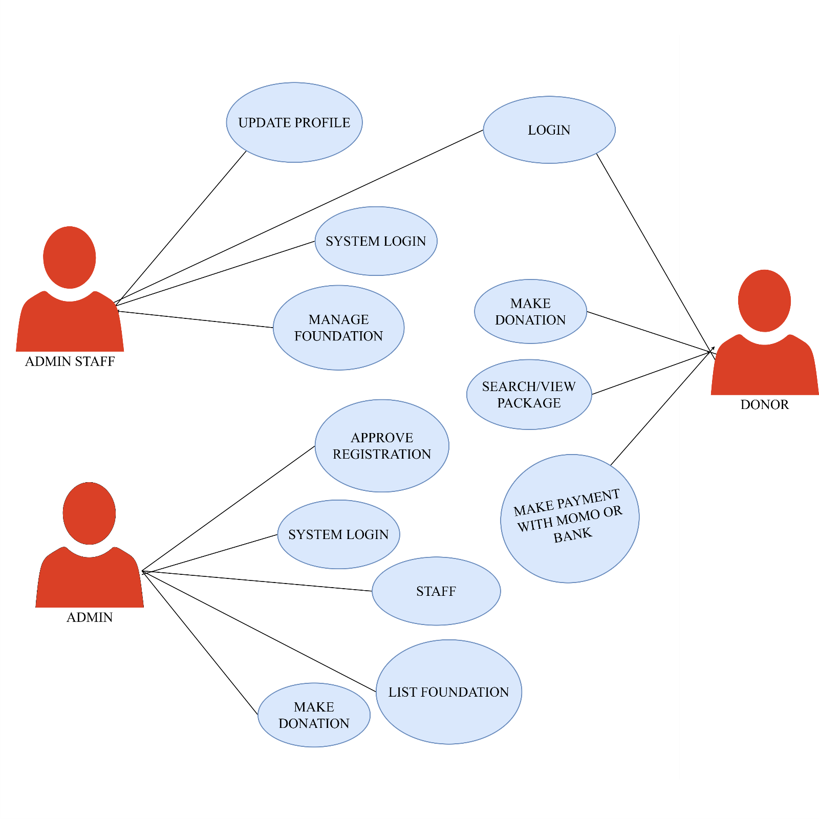
Fig. 3.3

3.5.2 Activity Diagram
An Activity Diagram is a visual model that represents the workflow of a task or action derived from a use case. It illustrates the step-by-step sequence of activities within a process, helping to clarify how tasks are executed and how information flows through the system. This diagram provides a clear understanding of the operational dynamics of the system, supporting analysis, design, and implementation.

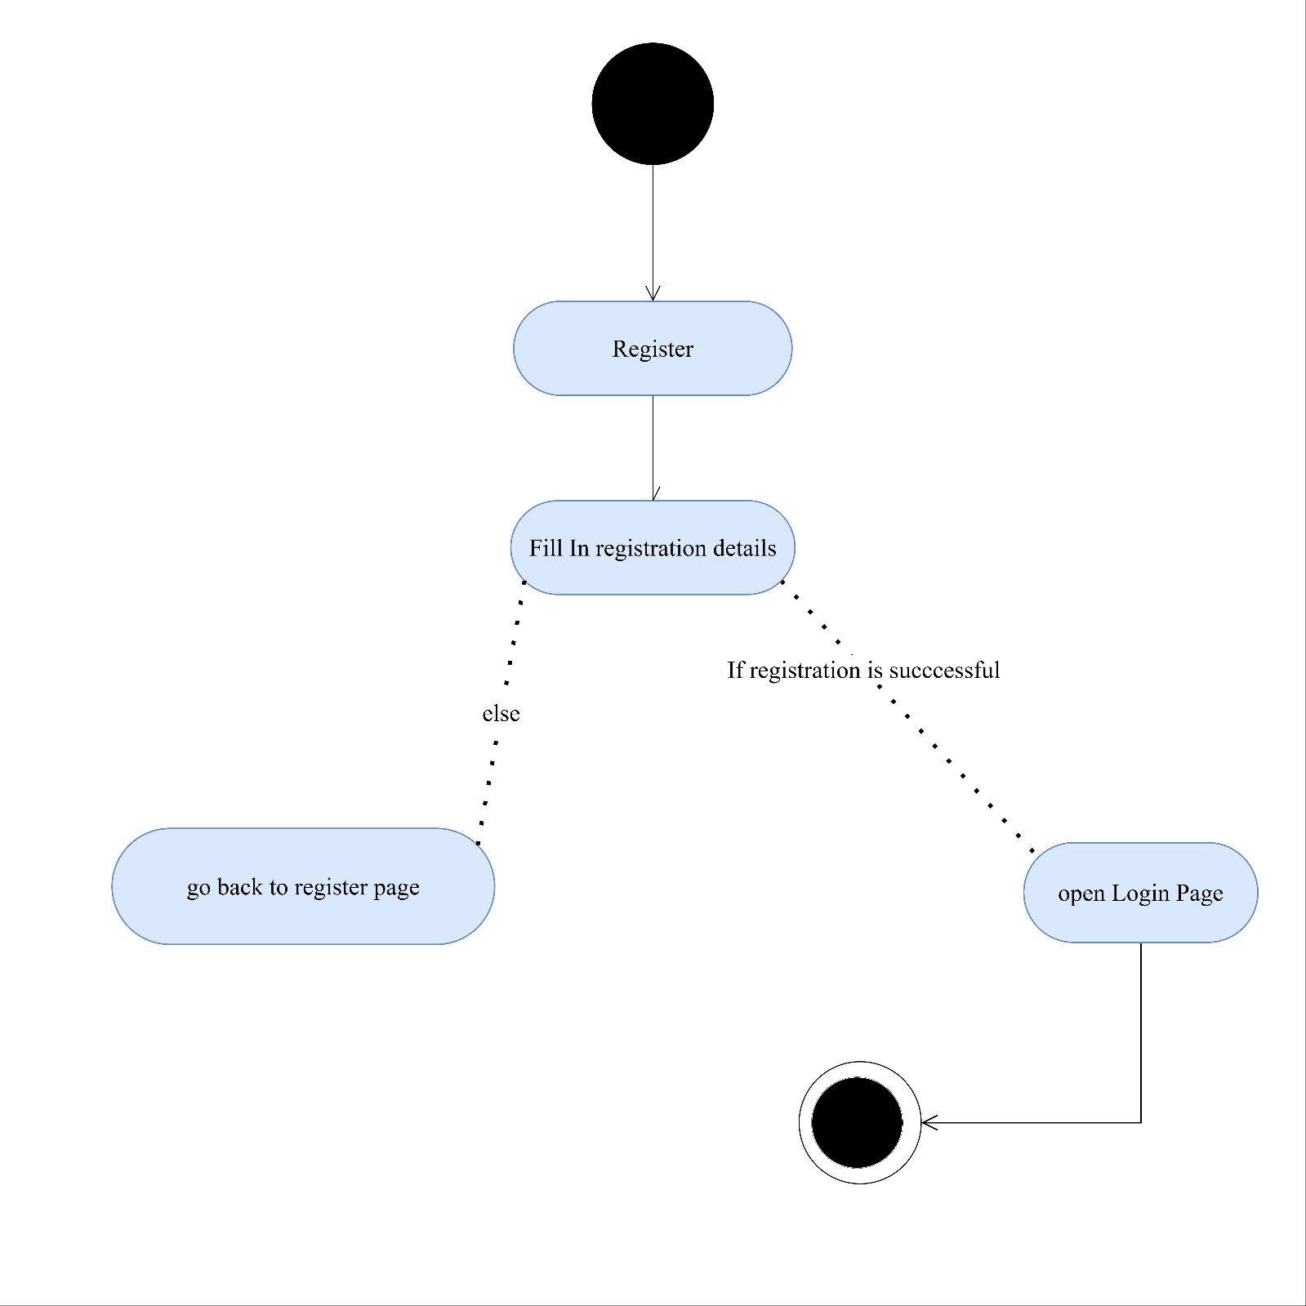
Fig. 3.4

3.5.3 Database design
The Campus Fundraising System database is designed to efficiently store and manage information related to users, campaigns, and donations. The design ensures data integrity, supports all system functionalities, and enables easy retrieval and maintenance.
Main Entities and Tables:
Users Table
- Attributes: user_id (PK), username, email, password, role (e.g., admin or regular user), date_created
- Purpose: Stores all registered users and their roles in the system.
Campaigns Table
- Attributes: campaign_id (PK), user_id (FK), title, description, goal_amount, amount_raised, status (e.g., pending, approved), date_created
- Purpose: Stores information about fundraising campaigns created by users.
Donations Table
- Attributes: donation_id (PK), campaign_id (FK), user_id (FK), amount, date_donated
- Purpose: Records all donations made by users to different campaigns.
Relationships:
- One user can create multiple campaigns (1-to-many).
- One campaign can receive multiple donations (1-to-many).
- Each donation is linked to one user and one campaign (many-to-1).
This database structure ensures proper organization, maintains relationships among entities, and supports the smooth operation of the Campus Fundraising System.

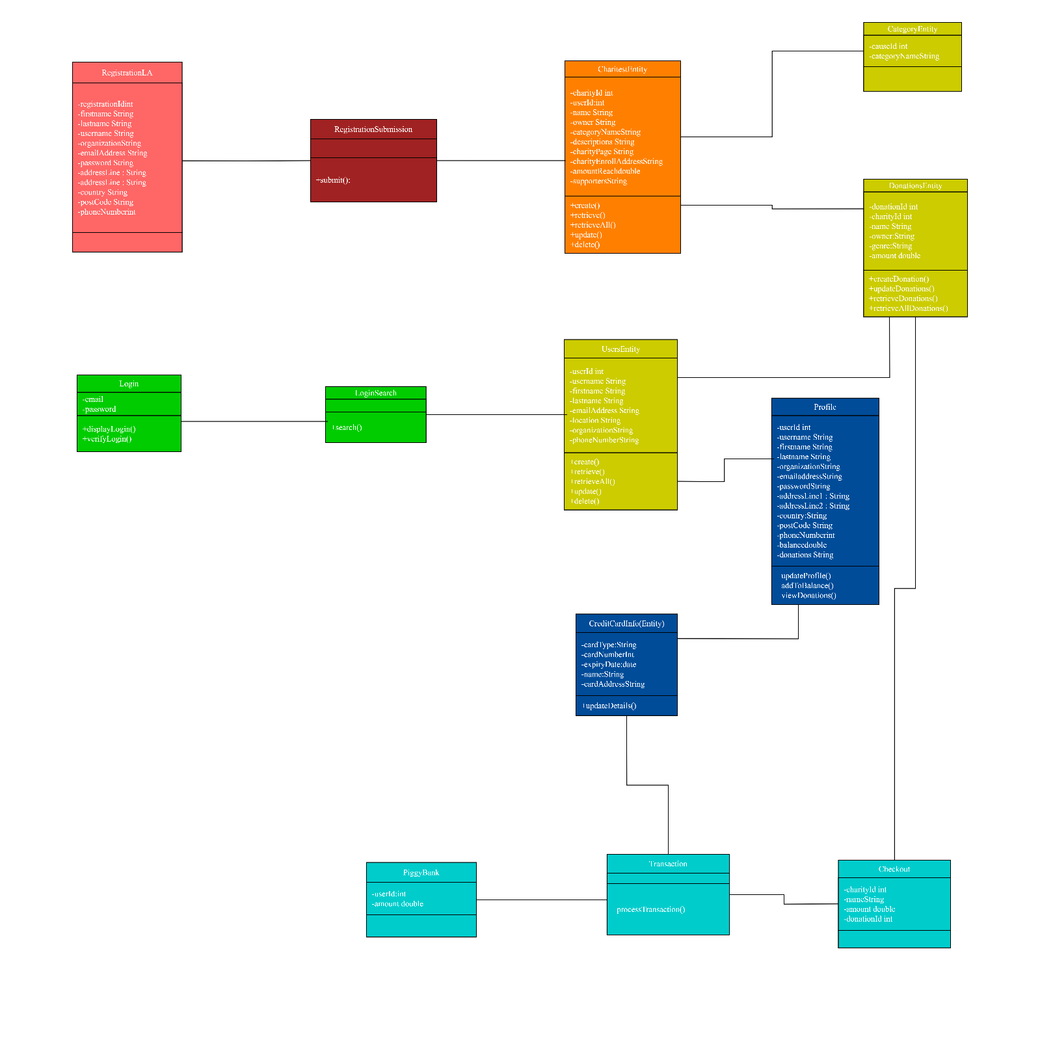
Fig.3.5

3.6 Methodology
The development of the Campus Fundraising System follows the Agile methodology, which emphasizes iterative and incremental development. This approach allows the system to be developed in small, manageable sections, ensuring continuous testing, feedback and improvement throughout the project lifecycle.
3.6.1 Chosen Methodology
Agile is suitable for web-based applications as it allows developers to build and refine system modules progressively. Key features include:
- Iterative development: System functionalities such as user registration, campaign creation, donation processing, and admin approval are developed and tested in successive iterations.
- Flexibility: Modifications and improvements can be incorporated quickly based on testing and user feedback.
- Collaboration: Promotes better coordination between developers and stakeholders, ensuring system requirements are met.
3.6.2 Application to the Project
The methodology guided the project development in the following ways:
- The frontend, backend and database components were developed in separate iterations.
- Each module, including login/authentication, campaign management, donation handling and admin approval, was tested individually before integration.
- Issues and feedback were addressed in subsequent iterations to enhance system performance and reliability.

3.6.3 Benefits of the Methodology
- Ensures structured and organized development.
- Facilitates early detection of errors and system improvements.
- Supports scalability, making it easier to add new features in the future.
- Enhances user satisfaction through continuous testing and refinement.

